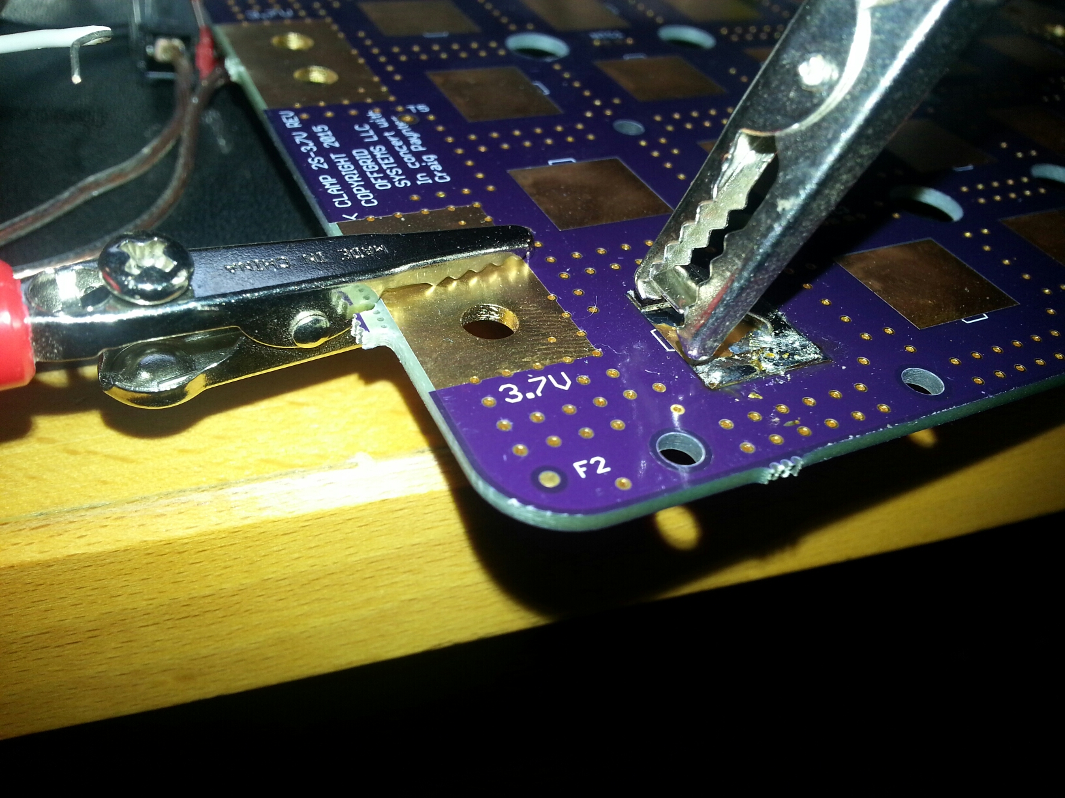
6 mil wide by 24 mil long
'thermal' spoke
X4 = 24mil total trace
width


Using traces as fuses, or more specifically using thermal relief 'spokes' as fuses.

Using trace width calculator at http://www.pcbco.com.au/tracecalc.html, it was found that a 24mil wide of 1 ounce trace thickness with 20 amps will fuse at 1000C which should be high enough temp to melt copper. Boards were built with a thermal relief comprised of 4 spokes each with a width of 6 mils = 24 mils total and then tested. So the width of each spoke is 6 mils and the length is 24 mils. Here are the test results.

Power supply = Sorenson DCS-150-20
Temperature = Fluke 62 Max IR thermometer
Temp probe = Fluke 80TK with K type small thermocouple probe
Ambient temperature = 21.7C
Test currents = 8A and 20.5ADC, 50 , 60 and 80ADC (where the fuses finally blew)
Two boards were tested = Clamp board – 2S-3.7V rev-- and Clamp board – 2S – 7.4-0V rev--
Board with fuse traces = Clamp board – 2S-3.7V rev--
Board without fuse traces = Clamp board – 2S – 7.4-0V rev--
Voltage drop test done by taking voltage drop from top of cell spring contact to via just outside spring contact pad

Board with fuse trace results:
Test for 40 min at 2C (8ADC) cell rating – 5degC rise after 40 minutes

Test at 5C (20ADC) cell rating:
1. 20degC rise after 2 minutes
- 30degC rise after 5 minutes – note spring contact area too hot to touch, significant heat coming from alligator clip attachment to spring contact. Measured 60C near fuse spokes with temp probe.
- Noted that spring contact to board voltage drop was 46mV or 0.046/20.5=2.24 milliohm, which is 883mW total or 220mw per fuse spoke
- Also noted that all four fuse traces were within 4degC of each other.

Test at high C rating to try and blow fuse(s)
  - Connect Dkpack as power source (7.4V) and electronic load as short circuit, and watch current on load meter. First try 40A, no blow for 2-3 seconds, allow to cool. Next 50 and 60A, still no blow, allow to cool. Test at 80A for 8 seconds and PCB traces fuses audibly 'pop' and current meter goes to 0A.
  - Picture of blown traces...(too small to see easily, must look under scope to see)

Board without fuse trace results:
Test at 20ADC with19degC rise after 5 minutes, max temperature found 45degC with temp probe. Max voltage drop of was 20mV or about 1 milliohm. Feeling around on the spring contact I believe most of the heat was generated from alligator clip attachment to top of spring contact.

